Chosen environment: Google Colab,
I’m completely new to running Python in a browser, so I checked Kaggle and Binder first. Kaggle looked good for data work and Binder seemed powerful, but both felt a bit complicated. Google Colab felt familiar because I already use Gmail and Drive, so I picked it.
Setup experience: When I opened Colab, it immediately let me create a “New Notebook” without installing anything or changing settings. That was a huge relief because I was worried I’d have to set up complicated stuff like Python versions or libraries. All I had to do was sign in with my Google account and start typing code in a cell.
Program written and executed:
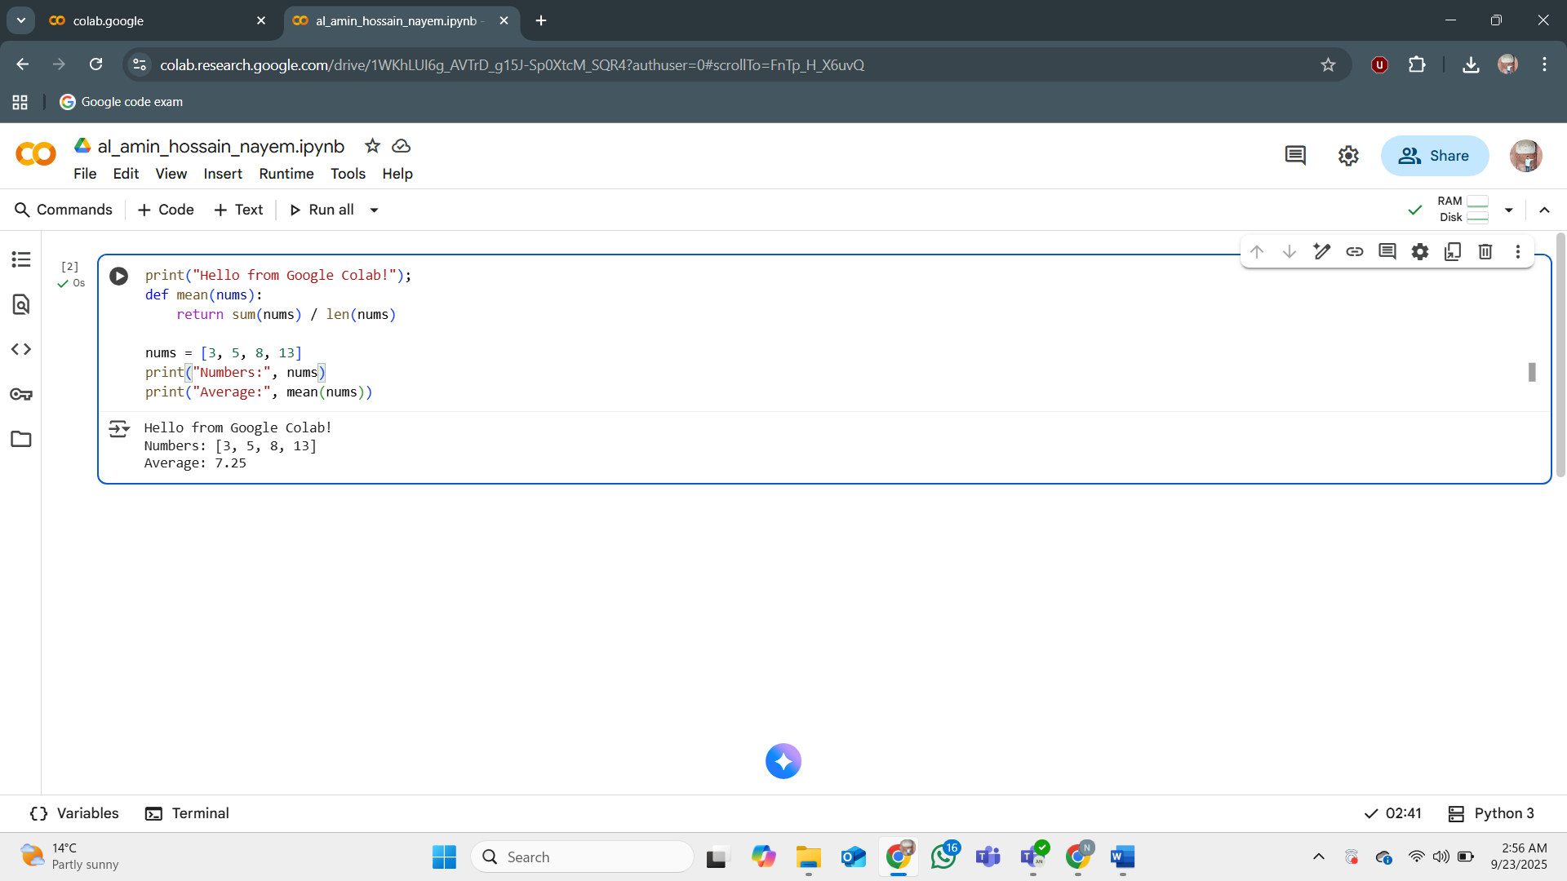
I ran a short Python script that printed a message, computed the average of a list. The code executed correctly, and outputs appeared directly under the cell.

Experience : I wrote a tiny program to print a message and square some numbers. Hitting the Run button worked on the first try, which was exciting for me because I was honestly expecting some kind of error. The only moment of confusion was figuring out how it saves the file. At first I thought I might lose my work, but once I saw the little “Saved to Drive” note, I relaxed.
Convenience and recommendation: Overall, Google Colab was super beginner-friendly. Everything is in the browser, there’s no installation, and it even saves my work automatically to Google Drive. For someone just starting with Python, I’d definitely recommend it—it let me focus on learning instead of messing with setup.

